Aura Cleansing
The aura cleansing meditation must be used from the day you start meditation onwards; it is a crucial meditation that needs to be used every day.
Cleaning your aura is a daily and essential need for anyone in spirituality.
Aura Cleansing is like taking a shower for the astral body, it wards off illness and keeps you protected against psychic attacks. Clean auras will actually imbue you with positive energies and help ward off negative ambient energy clusters.
At first aura cleansing should take place two to three times a day, for 10 to 15 minutes, until you feel it is at a decent level where you can lower it to morning and night or just once a day. When you get better at it you can add small tints of other wavelengths to program your aura for more particular functions.
In order to cleanse your aura:
1. Go into a trance state via the void meditation, even a light trance will do; it should not take very long.
2. Imagine a bright light engulfing your body, brilliant blue in colour, the colour of lightning, hold this for a few minutes you should feel it have an effect.
3. imagine the light getting even brighter and on each of your major chakras a concentrated orb of light like a miniature sun and hold that in your mind, if you feel you need to repeat it then do so until you feel clean.

Void Meditation
Void Meditation is quite simply learning to control your thoughts and body in order to easier achieve trance states, the more adept you are at this the more help it will be in higher level meditations and magic.
Void Meditation is very useful in Power Meditations and will be extremely useful in personal advancement.
As a starter meditation it will prepare you for the use of all the meditations to follow on this site, it will help you calm your mind, relax and can even be used in other situations where you need to concentrate.
There are many techniques to Void Meditation but we will just give you the basics as it is best for the individual to work on their own method as this will also make further progression easier.
When you attempt meditation at the start do so when you are fully awake, doing this when you are tired will make it very likely that you will fall asleep but as you get more adept you will most likely prefer times when you are tired as when the mind is in that state it is far more susceptible to energies and should open things to you far quicker than trying to calm your mind during an alert state.
The Basics
To start with you may want to find a quiet area in order to do this without disturbances, but as you go on you can perform this just as easily anywhere from on a bus to in an exam.
You can place yourself however you want although sitting cross legged is the most effective.
Note: you can perform this meditation with your eyes open or closed.
1. After finding the position you feel most comfortable to perform the meditation in, just loosen up and relax, try to find a small point of thought and concentrate on only that easing yourself into a blank mind.
2. as you do this try to regulate your breathing slow and deep, optionally you can choose a breathing pattern breathing in for a count of 6, holding for a count of 6 and then breathing out for a count of 6
as you make progress you will notice you have more control over your thoughts and if your eyes are open things will either be getting darker or misty and white, this is entering a trance state and is a good thing, from there you can perform many of the meditations to follow.
3. once your mind is in a state where you are free of thought, music tracks or anything else try to hold this state of mind (not your breath) for 15 minutes or however long you feel comfortable, try to do this on a daily basis until you feel ready to attempt other meditations.
Advanced Void Meditation
Visualize and hold an object in your mind, at first the image will fade in and out but will become more solid as you progress, this is very useful for magic as you will need to visualize targets or areas whether attacking or healing.
Focus on a chant known as a "mantra" which is a specific sound to help you focus your ability, this can be done out loud or in your head, the most common one used in yoga is the "Sa Ta Na Ma" chant pronounced "Sah-Tah-Nah-Mah" and lengthen it as you feel comfortable.
You can also focus on a specific emotion you wish to have more control over for example if you are an angry person you can learn to control this, emotion is a valid thing we should be proud to have but control is a necessity.
focusing on tastes, textures odours and such are also very useful to do.
The purpose of Advanced Meditation is to make your abilities stronger and your methods work through harder situations.
Practicing the Advanced Meditation is very similar to the basics but if you give yourself harder situations and more uncomfortable positions to perform it in it will teach you to overcome obstacles both physical and mental and will be very useful in advancement and personal well being.
Energy Meditations
There are a number of different energy meditations ranging from the basic intake of energy from around you to taking in energy from the sun, moon or even elements, in this meditation we will show you how to take in energy for beginners as well as solar and lunar energies.
Although this meditation is excellent for beginners as it gives one a feel for energy and sets the foundation to manipulate it. This meditation also strengthens the aura when done regularly, it is also keeps the user healthy and adds a good stock of energy for use in magick.
1. Begin by relaxing your entire body. The deeper the trance, the more effective, but this meditation can be done at any time and a trance is not necessary.
2. Breath in and as you do that draw in energy as if lightning blue electricity was diffusing into you from all sides of your body, front, back, top of your head and bottom of your feet. You should visualize blue brilliant light, like lightning. Working with colours is more advanced and most effective when you are a bit more experienced.
If you are doing solar or lunar energy make sure you are sat outside under the sun or moon and imagine an energy similar to either the brilliance of the suns or the sigh of the moon enter you.
3. Exhale and visualize the energy expanding your aura
4. Repeat step 2 and 3 several times but with each breath imagine your aura glowing brighter and brighter in strength.
When working with colours, visualize the colour becoming more and more powerful and vibrant. You will notice each colour has a different feel to it. Colours can be used to attract according to their nature.
You can also breathe in energy from the front and back sides of your body at the same time to meet in the middle, then do the sides and top and bottom. After this, let your aura expand outwards.
With this meditation, you can also practice expanding and contracting your aura.

Easy Chakra Spin
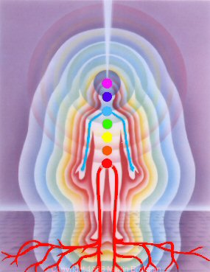
Disclaimer: Chakra colours are misrepresented by the image above. All chakras should be cleansed and empowered using electric blue energy only. No exceptions!
This meditation only takes a few minutes to perform so it can be done anywhere you have a moment to concentrate. Performing this meditation regularly can help ward off illness and misfortune. This meditation also makes us more receptive to astral energies as well as provides both astral and physical protection. Daily usage builds a strong energy field that increased each time it is performed although the meditation will have to be continued to retain any short term benefits.
When performing the meditation start with the base, or root, chakra moving upwards one chakra at a time. Make sure to focus on both ventral and dorsal circulation. First visualize your root chakra as a small, brilliant blue sun and gently push it to spin down ventrally, and up dorsally until it does so on its own. Then work your way up slowly to the sacral chakra and so on. Make sure as you move on you keep each previous chakra spinning in your visualization. An important note! When you reach the third eye chakra make sure to spin the energy more towards the center of your head, between the pineal gland and third eye and not at the surface of your forehead.
Depending on how strong your concentration, this is a nice way of cleansing your chakras since any blockages or negative energy clusters will be broken apart during a full chakra spin.

Clairvoyance
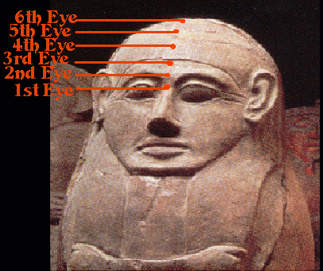

Using this meditation you can work on your astral vision, it is quick and easy.
1. Sit comfortably and enter into a trance, yes as usual the deeper the more effective.
2. close your eyes and physically look at your third eye without straining your muscles, just focus your sight upwards (even though your eyes are closed), usually you will see nothing but depending on your progression there can be swirling colours or even pictures.
3. Visualize your third eye shining brightly like a miniature sun, then move this energy slowly from the first to the sixth eye one by one as you inhale brightening them until they merge to one line of power that moves freely up and down from first to sixth, at this point keep the visualization of them in this way and concentrate on your third eye once more and let yourself open up to seeing more.
Clairsignation
Clairsignation is a brand new meditation based on the sensing of energy (the roots of both this word and meditation originate from the Aquarian path under Enki), it has been needed for a long time and here is why:
Whenever people meditate, whenever they contact any being their first reaction is to take whatever is said or presented to them at face value... notice the mistake?... well this is why so many people either become extremists or just generally fly off the handle and thatis why on this path we strive to teach each and every person exactly how to accurately contact the gods and how to identify any being from sensing it's energy alone.
there are a few steps to learning this ability, it starts with teaching you how to sense natural energy around you, trees, grass, plants... these energies are positive and abundant and will get you used to feeling energy, that is step 1 and is called the Nature Meditation, after that you learn to take it a step further by feeling the presence of energy on people you know, pick up on the different aspects that can match their personality weather positive or negative, once you feel you have mastered that you can test it by sensing people you don't know very well and finding out about them... finally once you have mastered those steps and feel pretty confident you can sense energies that can show us what a person is like and how healthy their energy is and more you can use this during your own meditations and rituals to help identify what if any beings are around you, weather it is an inquisitive spirit, a helpful god or a being pretending to be something it is not... Each of these steps will be clearly explained here but please do not move to the next one until you feel totally confident you have mastered the last, this ability is extremely important to Aquarians as it helps each of us identify what beings we are talking to and confirm our connection to the gods.

Nature Meditation
Further steps still to come

*This method was given by Enki to High Priest Shadderfer*

Circulating Energy
This Meditation can be quite powerful for those who have reached this stage of meditation and is used by martial artists and advancing members of the church to help get a feel for energy which in turn helps to control it.
To perform this meditation you need to have patience as it takes approximately 30 minutes and when you first start it can be difficult to feel the energy. It takes repeated meditations to begin to control the energy at will.
In this Meditation for a change you feel the energy rather than visualise it, feeling energy helps you to recognize different energy signatures which helps you to identify what is around you weather it is a presence of a god or a type of attack on you.
1. Focus on your crown chakra. Just sit 3-4 minutes and meditate on this chakra. You may feel it as a sort of crawling sensation, which is normal. When one advances or on occasion, there is an intense feeling of bliss. You may also feel a pressure there.
2. Now shift your focus to your third eye. Meditate on your third eye for several minutes. Feeling a pressure here is normal.
3. Move your attention now to your throat chakra and do the same as with the above two chakras.
4. Now move your energy to your heart chakra and focus for a few minutes the same as the previous chakras.
5. Focus now on your solar plexus and do the same.
6. Follow with your second/sacral chakra- do the same again.
7. Now focus on the area between your perineum. This is between the rectum and scrotum for men and between the rectum and vagina for women. This is a power spot. Visualise the energy glowing brightly like the sun here.
8. Move the energy to your base chakra and meditate for 3-4 minutes or so on your base chakra.
9. Now, direct the energy up your spine into your second chakra. (This is the second chakra located on your spine- with the first circulation, we focused on the chakras in the front, we are now directing the energy up the back).
10. Continue to do the same, directing the energy up into each chakra, one by one located in the spine, until you reach your crown.
11. This time, you can direct the energy without pausing, moving it along down the front of your body chakra by chakra until you stop again at the perineum and direct the energy up your spine.
Keep circulating the energy as long as you wish. This exercise will enable you to control and direct energy. This is small step to controlling a lot of power later on. You will establish a mind connection to where you are able to focus and the energy will follow. This can be used for healing, empowering or otherwise.

Planet Meditation
Due to thousands of years of damage both spiritually and physically, our planet is left in a severely depleted state, its once plentiful energies destroyed by christianity, idiot cults sending energy to the heavens, mistaken people using it without respect and of course basic human greed, but, there is something we can do.
This meditation is placed as an intermediate so that people who attempt it have already made sure their energy levels are well balanced after practicing the beginners section, it is also recommended that you be dedicated to or working toward dedicating on the Aquarian path due to our abundant use of natural energy which will be the best to use for this situation.
For this meditation you will need a point down pentacle (one without the circle around it), it does not need to be a pendant and you can make one yourself. It is also recommended to be standing outside on natural ground barefoot. You will also be pushing energy through your foot chakras so it is best to have practiced this for a while.
This meditation can be programmed to work constantly for those more advanced and comfortable in order to let your natural excess energies to constantly flow into the earth instead of dissipating around you.

First of all you will need to sit down and enter a basic trance, as usual the deeper the better, from here start to perform the basic energy meditation, take in as much energy as you can but use your aura to seal it in, see your whole body fill with as much blue energy as you can and swirl it around, careful however this can make you feel a little nauseous and dizzy as you compact a large amount of excess energy.
Next you will need to head outside, if you are already there just stand up holding your pentacle point down in both hands in front of your heart chakras, focussing on it start to see your energy slow down from its swirling and open your foot chakras, at this point see the energy flow slowly out of your foot chakras and spread slowly into the plant itself, although you will notice this is a very small amount of energy flowing out by repeating this meditation daily you will be replenishing the energy as well as programming your aura to lock energy in and release the excess slowly into the planet automatically, be sure to cleanse often and for those who are advanced enough you can create a stationary energy platform in your shins to block any negative energy from passing.
And that is all it takes, lets just hope more and more people decide to start using this meditation and the planet can finally start to heal.

The third eye is linked with the pineal gland and is the window of vision into the astral realm, by opening this window you get to experience, see and even begin to hear things you never thought possible, a world beyond imagination and full of wonder and knowledge, but it is also full of danger, so be careful when proceeding on the path.
Important: Once you have Opened your third eye please give at least two weeks before attempting the next awakening (for others it will only take one week, once you feel no more effect from the meditations from one to two weeks and feel you are ready to move to the next awakening then do so), it is vital you perform Daily meditations on your third eye for this period as it allows your body to adjust to the energy flow and allows you to prepare yourself.
This exercise is done with a specific tone and chant. You need to do this exercise for four days in a row. On completion of this you should still do some extensive work on your third eye, just because it is open does not mean it is strong, so by empowering it daily you will get it used to being in use, this way in time you will start to see images or colours with it if you continue daily empowering which is basically meditating and attempting to look through it for 10 minutes or so a day, if you think you can manage it work on it for anywhere up to two hours at a time. If you have never used your eyes before they will not work very well, but after frequent use and given time to strengthen they will stop hurting and form a picture, the same rule applies here. You may use the mantra any time you are meditating on your third eye, but if you only use it for the Awakening then meditating without it during the empowering it will allow you to feel and get used to your third eye with a higher level of control, even though it may take slightly longer.
The mantras to be used is "Th" pronounced "Though" followed by "Thoooooo" as in "moon." Use whichever one you can feel best vibrating in the centre of your forehead.
When performing this meditation keep trying the mantra until you can feel it vibrate where your third eye is (as shown in the picture), once you have that tone right you can begin.
1. Sit with your back straight, preferably cross legged on the floor.
2. Place your hands in the position as shown in the photos. For people who are right handed, your right hand should make a fist around your left index finger; for people who are left-handed, your left hand should make a fist around your right index finger. The thumbnail should press on the side of the finger as shown, at the spot where the cuticle ends. When you feel a very faint electrical shock, you will know you have the correct spot. Don't get discouraged if you cannot find it. It should be apparent in those who have naturally stronger auras. What this does is redirect the flow of energy to the third eye.
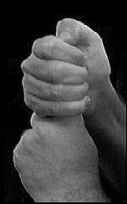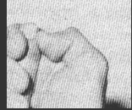
3. Breathe in through your nose and hold your breath as long as is comfortable- open your mouth so there is a small space between your top and bottom teeth, place the tip of your tongue between the space of your slightly parted teeth to make the English "TH" sound.
4. Once your tongue is in position, release your breath slowly through your mouth saying T-H-H-O-H-H (rhymes with the English word "Though"
or T-H-H-H-O-O-O-O-O as in the English word "moon" in one long exhale (vibrate the sound one time per exhale, you may not have the timing perfect but do it the best you can. Your tongue will be vibrating between your teeth. It may take a few seconds to adjust this to where you feel it in the middle of your forehead (3rd eye), don't worry, just keep on going.
5. Repeat step 4 another three times in a row and then take a deep breath and relax.
6. It is very important the above exercise be done for FOUR consecutive days, preferably 24 hours apart. Then it is a done deal and you will have performed the initial step of opening and activating your third eye.
Once you have done this remember to meditate on your third eye on a daily basis if you actually want it to be of any use to you.
You can expect to feel a light headache in the process of this on days one, two and four, do not me alarmed if you do not feel as much on day three, on completion you will feel these headaches as well but they will slowly subside (warning: some people may experience large migraines but do not worry, it will stop). With continued work on your third eye you will also experience colours swirling and shadows moving among other things.
The Crown Chakra and Pineal Gland
Before you start this meditation it is important to have completed the third eye awakening and to have waited two weeks after doing so. This should have given you enough time to start empowering your third eye as well, you can perform this seven days after opening your third eye so that your body has time to adapt but the extra week is far safer and gives you more time to prepare and work on your third eye meditation on a daily basis.
The good thing about the following meditation is you only need to perform it once, unless you do not feel the effects anywhere up to a week later.
The Pineal gland is highlighted on this picture and the crown chakra (straight up above it on the top of your head) are what we will be focusing on in this meditation.
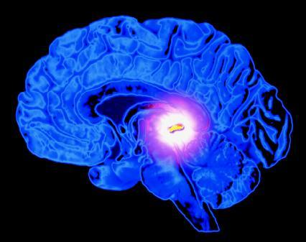
This Exercise is very enjoyable, and will produce tingling and even light energy orgasms as well as pressure on your crown chakra, the effects will allow you to see and feel energy much better as well as allow for astral projection later on.
The Pineal gland is the window to our astral body. It is the "psychic seat of the soul" so to speak, and with continued meditation it will grow and become more active. Again as with the third eye you should be performing daily meditations on the pineal gland and the crown chakra after the awakening.
Although this meditation is very effective it can, and most likely will, produce intense headaches. This meditation should only be performed for opening the crown chakra, once it has been opened you will experience a sensation of bliss but if you have not felt this up to a week after you have performed the meditation you may need to repeat it, but after this initial exercise, there are different meditations you can do to activate your pineal gland and stimulate your crown chakra further.
1. Breathe in deeply and hold your breath for a count of 4, do this 5 times. This helps you to be relaxed, focused and enter into a trance state, take your time none of this needs to be rushed. Then focus all of your concentration on your 3rd eye. You should begin to feel a slight pressure sensation or awareness of your 3rd eye, this is where the preparation comes in allowing you to get used to using your third eye.
2. Put your hands before your stomach. Let the ring fingers point up, touching at their tops. Cross the rest of your fingers, with the left thumb underneath the right.
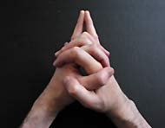
Take a Deep breath as with the third eye meditation and hold the mantra as long as you feel comfortable, release your breath vibrating b-b-b-b-b-b-b-b (vibrate with a deep, soft hum with the lips almost closed) The vibration should sound like a bee. It is OK to adjust your pitch. You should focus on and feel the vibration in your third eye, then focus on your pineal gland. You should be 1/3rd the way through of your drawn out vibrating exhale and feel the vibration in your pineal gland. Then focus on your crown chakra and feel the vibration in your crown chakra and continue to extend your exhale as long as you are able to. Breath in again, repeat this 4 times.
This exercise is extremely powerful.
VERY IMPORTANT:
Remember to concentrate on your forehead (3rd eye area), then your pineal gland and finally your crown chakra. You should regulate the exhale so it evens out. This is done for the duration of each chant.
Summary:
1. Breath in
2. Begin to exhale, vibrating b-b-b-b-b-b-b-b
3. Concentrate on and feel the vibration in your 3rd eye
4. Concentrate on and feel the vibration in your pineal gland
5. Concentrate on and feel the vibration in your crown chakra
Repeat 3 more times for a total of 4 times.

Opening the Hand Chakras
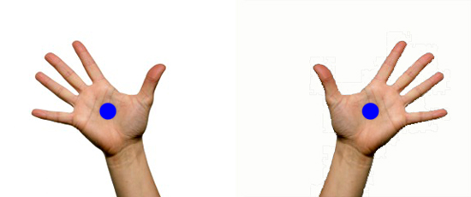

When this meditation is done regularly it works to produce a clear pathway of energy through the hands which can be used for many things such as healing, telekinesis and even the "death touch" (Dim Mak), and even Pyrokenesis. These abilities do need a strong aura in order to perform and daily exercise to empower the hand chakras are needed, but do not try to rush into these abilities as they can take years to develop.

1. Sit comfortable and try to get into a trance, as usual the deeper the trance the better the effect.
2. Press the face of your thumb into the hollow of each palm.
3. place hands facing each other and relaxed, fingers can be bent as long as the palms of your hands are facing each other and your hands are not touching.
4. Focus on the palms of your hands where you have pressed your thumbs and imagine energy slowly moving through your arms to that point, try to feel the energy flow as this happens.
5. Keep your focus here and begin to push the energy out of your hands and concentrate it into a ball between your hands., you will feel a warmth growing between your hands as this happens.
6. begin to move your hands an inch or two apart and then back to the point your finger tips almost touch, the more you practice and stronger you get the further you can do this and still feel the energy flow.
7. Begin to build the energy ball up now into a white how sun, keep doing this until you feel the energy as heat, cold or even a tingling or throbbing, but make sour that you feel it.
8. now relax your arms and just concentrate on the energy flow through them.
9. Repeat steps 1 through 8 four more times.

Opening the Throat Chakra

This meditation will help you communicate on the astral as well as more easily sway people with your words.
This meditation should be performed once a week for as long as is needed.
1. Go into a trance, as usual the deeper the trance the more effect it will have.
2. place your hands into the position as shown in the picture below, Note: do not fold thumbs over each other.
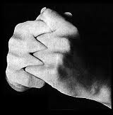
3. Take a deep breath, hold as in the other awakening exercises and then chant: a-a-a-a-a-a-a-a-a-h (as in awe with a steady exhale) until your breath is fully released.
Remember to adjust it until you feel it on your throat chakra, this can take some practice.
4. Repeat this another 6 times.
Opening the Heart Chakra
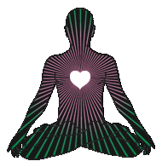
The Heart Chakra is the Centre of our power, it is where we derive our control, our strength and our defence from, controlling your heart chakra you can control your actions with far better accuracy, by pushing energy and intention through your heart chakra you can increase your power a huge amount, like a burst of adrenalin you explode with ability, by focusing rage or any feeling through it you increase it as well as your power. But at the same time the heart chakra provides balance and control.
Again once you have opened this chakra it is important to work on empowering it.
1. To start with Cross your arms over your chest and put your hand in the position shown below (make sure thumb connects with pinkie and ring finger leaving the other two pointing straight) and enter a trance, as usual the deeper the more effective.

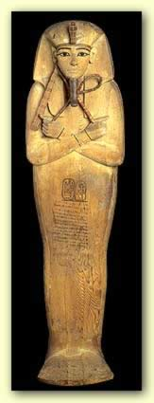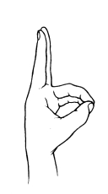

2. Take a deep breath and lower your head and press it against your chest and whilst you focus your attention on the heart chakra chant "K-A-A-A-A-A-Y" as you exhale remembering to extent the "A-A-A-Y" part for as long as you feel comfortable.
3. Visualize yourself completely engulfed in a brilliant green light.
4. Repeat the above eight times more and then focus on your heart chakra for several minutes.
It is important to meditate on your heart chakra after opening it and learn to use it as once your heart chakra is active it can amplify emotions creating situations where you will be angry at even close friends and take arguments too far or seriously, by working on your heart chakra you can learn to control your emotions in case this happens.
Humanity is said to be unique due to our emotions but those who have opened their heart chakra experience emotions to a far higher degree as do the Gods.
Solar Plexus
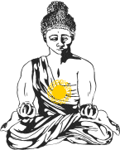
The solar plexus is located in the curve of bone under your diaphragm.
This is a reasonably quick and easy Awakening.
1. Sit with your spine straight and enter a trance, as usual the deeper the trance the more effect it will have, once there place your hand in the position shown below.
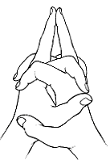
2. Breath in deeply and press your chin against your chest and as you exhale chant "Y-Y-Y-Y-Y-Y-Y" as in "Year" whilst concentrating on your solar plexus chakra, remember do this for as long as you feel comfortable and adjust the tone until you feel it on the solar plexus chakra.
3. Repeat this five more times.

Base Chakra Awakening
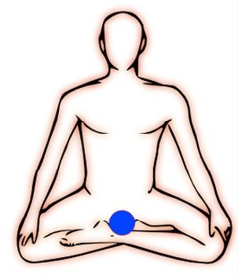
This Chakra is located at the base of your spine; the end of your tailbone.
1. Enter a trance state via void meditation; the deeper the trance the better.
2. Place your hands as shown below, with the back of your middle and index fingers touching.
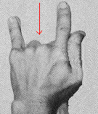
3. Take a deep breath and as you exhale make a hissing sound for the mudra "s-s-s-s-s-s-s-s-s-s-s-s-s", (do this for as long as you feel comfortable do not over do it). While doing this, imagine your base chakra as a miniature electric blue sun, growing brighter.
Opening the Foot Chakras
This exercise is done standing. Relax and "breathe" in energy through the bottoms of your feet, mainly your heels. The feet chakras tie directly into the base chakra and sacral chakra. This may result in stimulating your sex organs as well as the feet are tied to orgasm.
this is done quite easily, as you breathe in slowly and deeply you imagine electric blue energy flowing in your foot chakras from the ground.
Continue drawing the energy up through your feet. up your legs into your base chakra and up your spine and out your crown. Continue breathing the energy in for a few minutes.
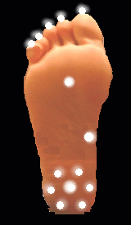

Sacral Chakra Awakening
The Sacral Chakra is located just above the Genitals, just where the fingers overlap on the picture above.
1. Enter a trance state, again as usual the deeper the trance the better
2. place your hands as shown below, do not fold your thumbs.
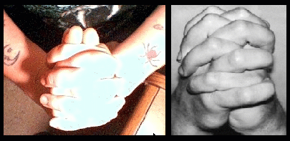
3. inhale and touch your chin to your chest and contract your anus.
4. exhale and chant the mantra "I-I-N-N-N-N-G-G-G-G-G-G-G-G-G" (as with the English word "Thing.") and concentrate on your sacral chakras (one an inch below the belly button and one as shown in the picture at the top of the page)
5. Repeat the above eight times. When you are finished, visualize yourself in an orange aura for a few minutes while focusing on feeling your sacral chakra.

